**SUMMARY REPORT YEAR 2021**

*Báo cáo tổng hợp năm 2021*

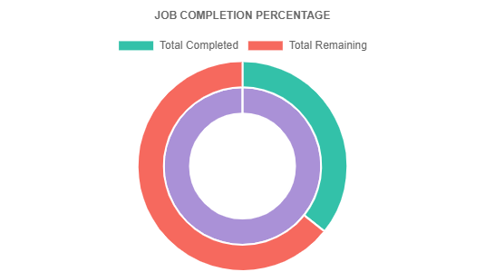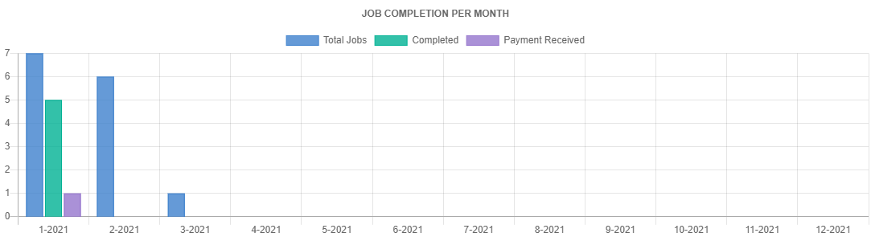

|  |  |  |  |  |  |
| --- | --- | --- | --- | --- | --- |
| **Month - Year** | **Total Jobs** | **Completed** | **Remain** | **Payment Received** | **Payment Pending** |
| 1-2021 | 7 | 5 | 2 | 1 | 0 |
| 2-2021 | 6 | 0 | 6 | 0 | 0 |
| 3-2021 | 1 | 0 | 1 | 0 | 0 |
| 4-2021 | - | - | - | - | - |
| 5-2021 | - | - | - | - | - |
| 6-2021 | - | - | - | - | - |
| 7-2021 | - | - | - | - | - |
| 8-2021 | - | - | - | - | - |
| 9-2021 | - | - | - | - | - |
| 10-2021 | - | - | - | - | - |
| 11-2021 | - | - | - | - | - |
| 12-2021 | - | - | - | - | - |
| TOTAL | 14 | 5 | 9 | 1 | 0 |